**AI-powered Nutrition Analyzer for Fitness Enthusiasts**

**NALAIYA THIRAN PROJECT BASED LEARNING ON PROFESSIONAL READINESS FOR INNOVATION, EMPLOYMENT AND ENTREPRENEURSHIP**

**A PROJECT REPORT**

**BY**

**JOTHIKA C(621119106012) JENIFER A(621119106010) KALKI P(621119106013) RESHMA S(621119106019)**

**TEAM ID:**

**INDUSTRY MENTOR: Sri Tulasi**

**FACULTY MENTOR: Siva priya**

**BACHELOR OF ENGINEERING**

IDHAYA ENGINEERING COLLEGE FOR WOMEN

## INDEX

1. **INTRODUCTION**
   1. Project Overview
   2. Purpose
2. **LITERATURE SURVEY**
3. **IDEATION & PROPOSED SOLUTION**
   1. Empathy Map Canvas
   2. Ideation & Brainstorming
   3. Proposed Solution
   4. Problem Solution fit
4. **REQUIREMENT ANALYSIS**
   1. Functional requirement
   2. Non-Functional requirements
5. **PROJECT DESIGN**
   1. Data Flow Diagrams
   2. Solution & Technical Architecture
6. **PROJECT PLANNING & SCHEDULING**
   1. Sprint Planning & Estimation
   2. Sprint Delivery Schedule
   3. Reports from JIRA
7. **CODING & SOLUTIONING (Explain the features added in the project along with code)**
   1. Feature 1
   2. Feature 2
8. **TESTING**
   1. Test Cases
9. **RESULTS**
   1. Performance Metrics
10. **ADVANTAGES & DISADVANTAGES**
11. **CONCLUSION**
12. **FUTURE SCOPE**
13. **APPENDIX**

Source Code

GitHub & Project Demo Link

# INTRODUCTION

## Project Overview

Food is essential for human life and has been the concern of many healthcare conventions. Nowadays new dietary assessment and nutrition analysis tools enable more opportunities to help people understand their daily eating habits, exploring nutrition patterns and maintaining a healthy diet. Nutritional analysis is the process of determining the nutritional content of food. It is a vital part of analytical chemistry that provides information about the chemical composition, processing, quality control and contamination of food.

The main aim of the project is to build a model which is used for classifying the fruit depending on the different characteristics like color, shape, texture etc. Here the user can capture the images of different fruits and then the image will be sent to the trained model. The model analyzes the image and detects the nutrition based on the fruits like (Sugar, Fibre, Protein, Calories, etc.).

## Purpose

As the world is growing more fitness-conscious with time, there is an increasing demand for advanced technological solutions to cater to it. Lately, many applications worldwide are using predictive analytics artificial intelligence as well as natural language processing to help scores of fitness enthusiasts to monitor their nutrition and calorie intake. Artificial Intelligence and its subsets have been leveraged by these platforms to identify the calorie intake and then make food recommendations for a healthy diet.

# LITERATURE SURVEY

1. **Deep Food : Food Image Analysis and Dietary Assessment via Deep Model.** This system will analyze the nutritional ingredients based on the recognition results and generate a dietary assessment report by calculating the amount of calories, fat, carbohydrate and protein.

### ALGORITHMS USED:

* + Region-based Convolutional Neural Network
  + Convolutional Neural Network
  + Non-maximum suppression
  + Bounding Box Regression
  + Deep learning techniques

### CHALLENGES:

Three main challenges in real food image recognition and analysis are addressed as follows:

1. Region of Interest
2. The Delay of Food Recognition
3. Insufficient Information of Nutrition Content for dietary assessment

### [2]A New Deep Learning-based Food Recognition System for Dietary Assessment on An Edge Computing Service Infrastructure

A design of food recognition system employing edge computing-based service computing paradigm to overcome some inherent problems of traditional mobile cloud computing paradigm, such as unacceptable system latency and low battery life of mobile devices.

### ALGORITHMS USED:

* + K-means clustering algorithms
  + Convolutional Neural Network
  + Bounding Box Regression
  + Deep learning

### CHALLENGES:

Using this simple cropping-based approach will not work well if the food is scattered on different parts of the image

### Precision Nutrient Management Using Artificial Intelligence Based on Digital Data Collection Framework

Nutritional intake is fundamental to human growth and health, and the intake of different types of nutrients and micronutrients can affect health. The content of the diet affects the occurrence of disease, with the incidence of many diseases increasing each year while the age group at which they occur is gradually decreasing.

### ALGORITHM USED:

* + Okapi BM25
  + TF-IDF
  + Levenshtein
  + Jaccard
  + Synonyms

### CHALLENGES:

This model has very little error and can significantly improve the efficiency of the analysis.

### Calculating Nutrition Facts with Computer Vision

People are becoming more health-conscious than before. However, there is a lack of knowledge about different fitness and wellness aspects of food. Thus, I come up with Foodify.ai — a deep

learning-based application that detects food from the image and provides information of food such as protein, vitamins, calories, minerals, carbs, etc.

### ALGORITHM USED:

* + Deep learning
  + Machine learning
  + Image Processing

### CHALLENGES:

1. This is to collect images to create a huge dataset.
2. This is related to training the deep learning model. It is an extremely computationally expensive and time-consuming task to train the model again and again. This can be solved by using cloud-based service

# IDEATION & PROPOSED SOLUTION

## Empathy Map Canvas

An empathy map is a simple, easy-to-digest visual that captures knowledge about a user’s behaviors and attitudes.

It is a useful tool to help teams better understand their users.

Creating an effective solution requires understanding the true problem and the person who is experiencing it. The exercise of creating the map helps participants consider things from the user’s perspective along with his or her goals and challenges.

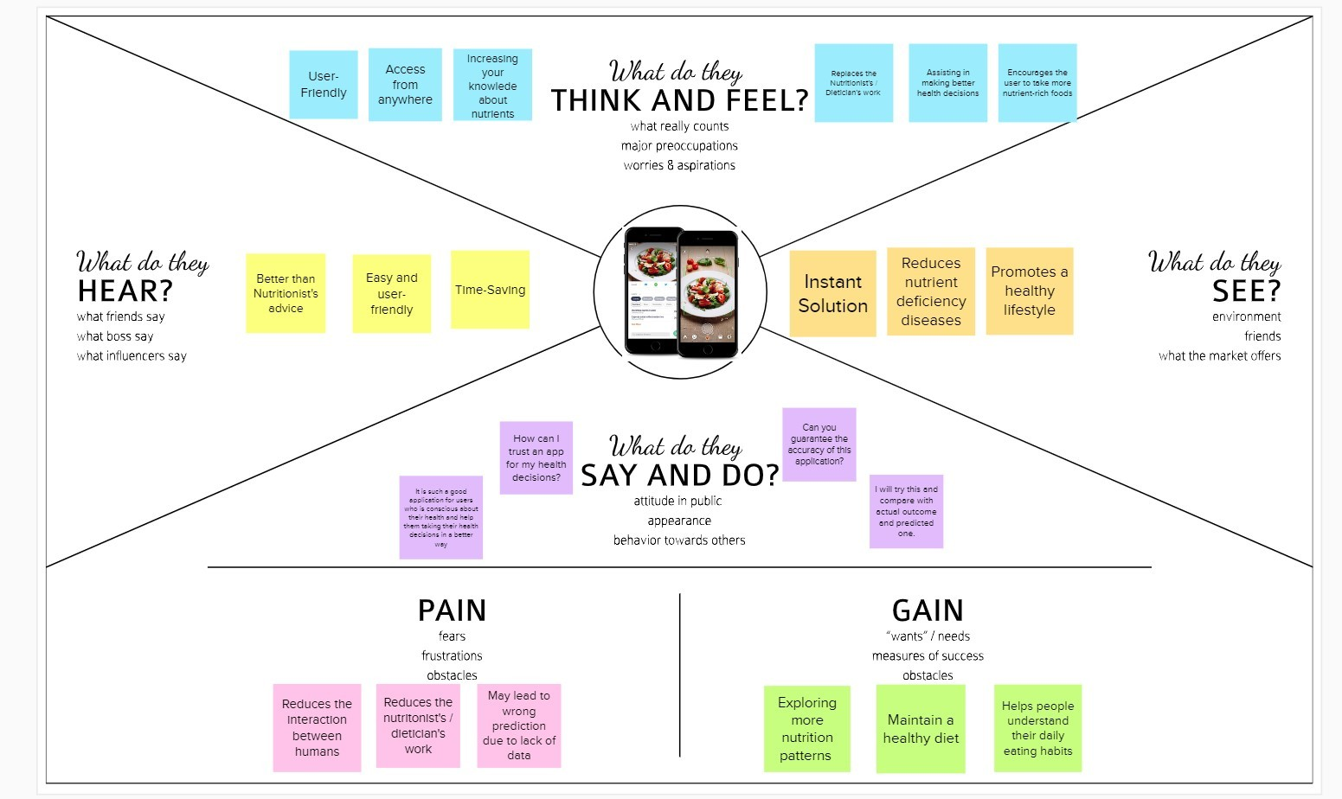

## Ideation & Brainstorming

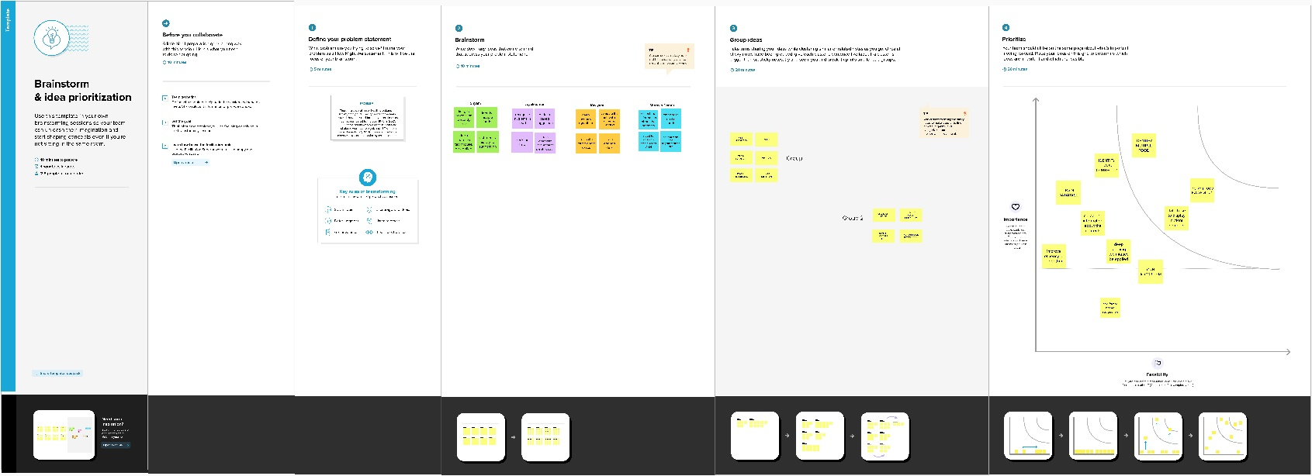





## Proposed Solution

|  |  |  |
| --- | --- | --- |
| **S.No.** | **Parameter** | **Description** |
| 1. | Problem Statement (Problem to be solved) | Food is essential for human life and has been the concern of many healthcare conventions. Nowadays new dietary assessment and nutrition analysis tools enable more opportunities to help people understand their daily eating habits, exploring nutrition patterns and maintaining a healthy diet. Nutritional analysis is the process of determining the nutritional content of food. It is a vital part of analytical chemistry that provides information about the chemical composition, processing, quality control and contamination of food. |
| 2. | Idea / Solution description | The idea of the project is to build a model which is used for classifying the fruit depending on the different characteristics like color, shape, texture etc. |
| 3. | Novelty / Uniqueness | Here the user can capture the images of different fruits and then the image will be sent to the trained model. The model analyzes the image and detects the nutrition based on the fruits like (Sugar, Fibre, Protein, Calories, etc.) |
| 4. | Social Impact / Customer Satisfaction | This project is very helpful to People. Everyone Maintaining their own diet, to manage the time. |
| 5. | Business Model (Revenue Model) | By using this system, the users can predict and analyze the picture of the fruits and foods. In which it results in visualizing the description of the foods taken as input. |
| 6. | Scalability of the Solution | By implementing this system, the people can efficiently and effectively gain knowledge about the fitness.They want and they wish to use at any time. This system can also be integrated with the future technologies |

* 1. **Problem Solution fit**

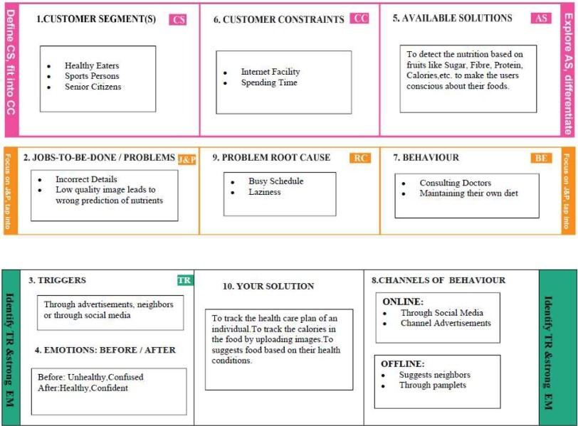

# REQUIREMENT ANALYSIS

## Functional requirement

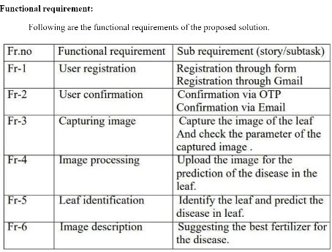

* 1. **Non-Functional requirements**

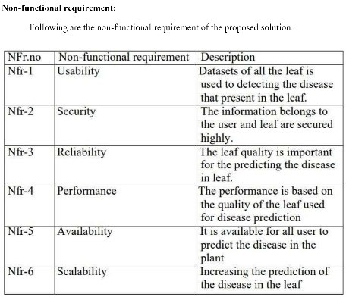

# PROJECT DESIGN

## Data Flow Diagrams

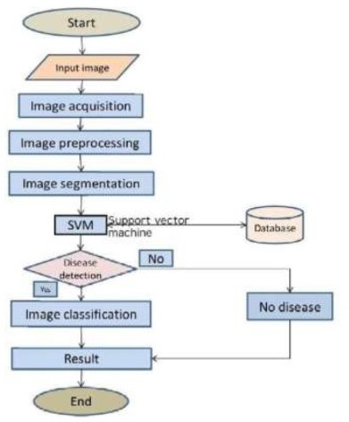

* 1. **Solution & Technical Architecture**

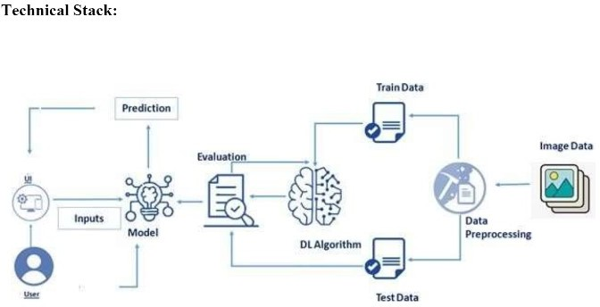

**Solution Architecture:**

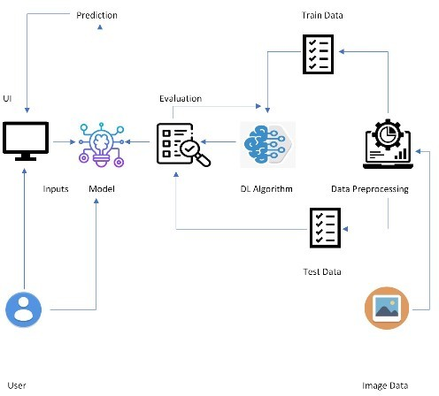

# PROJECT PLANNING & SCHEDULING

## Sprint Planning & Estimation

|  |  |  |  |  |  |
| --- | --- | --- | --- | --- | --- |
| **Sprint** | **Functional Requirement (Epic)** | **User Story / Task** | **Story Points** | **Priority** | **Team Members** |
| Sprint-1 | Registration | As a user, First I have to register for IBM cloud | 2 | High | Jothika,  Jenifer,  kalki,  Reshma |
| Sprint-1 | Collecting the datasets | As a user, I have to collect and download the datasets | 2 | High | Jothika,  Jenifer,  kalki,  Reshma |
| Sprint-1 | Image Preprocessing | After collecting the datasets,Image Preprocessing has to be done | 2 | Medium | Jothika,  Jenifer,  kalki,  Reshma |
| Sprint-1 | Model building | After image preprocessing, user has to build the model | 2 | High | Jothika,  Jenifer,  kalki,  Reshma |
| Sprint-2 | - | As a user, I have to develop a code for this model building and I have to build a model | 2 | High | Jothika,  Jenifer,  kalki,  Reshma |
| Sprint-2 | Application building | After model building,I have to create an application for the end users | 2 | High |  |

|  |  |  |  |  |  |  |
| --- | --- | --- | --- | --- | --- | --- |
| Sprint-3 | - | USN-7 | As a user, I have to Create a folder which contains all the necessary html, css,js and python coding files | 2 | Medium | Jothika,  Jenifer,  kalki,  Reshma |
| Sprint-3 | - | USN-8 | I have to create a folder name flask,where I have to paste all the above mentioned coding files in that folder | 1 | High | Jothika,  Jenifer,  kalki,  Reshma |
| Sprint-4 | Outputs | USN-9 | Link the flask file with html files and I have to share the screenshots of the output webpage | 2 | High | Jothika,  Jenifer,  kalki,  Reshma |
| Sprint-4 | - | USN-10 | As a user, I have to deploy the model on IBM | 2 | High | Jothika,  Jenifer,  kalki,  Reshma |

## Sprint Delivery Schedule:

The delivery plan of project deliverables is a strategic element for every Project Manager. The goal of every project is, in fact, to produce a result that serves a specific purpose. With the word “purpose “, we can mean the most disparate goals: a software program, a chair, a building, a translation, etc.

In Project Spirit Delivery Planning is one of the processes of completing the project and Showcasing the TimeLine of the Project Planning.

This Delivery plan helps to understand the process and WorkFlow of the Project working by the Team Mates.

Every Single Module are assigned to the teammates to showcase their work and contribution of developing the Project.

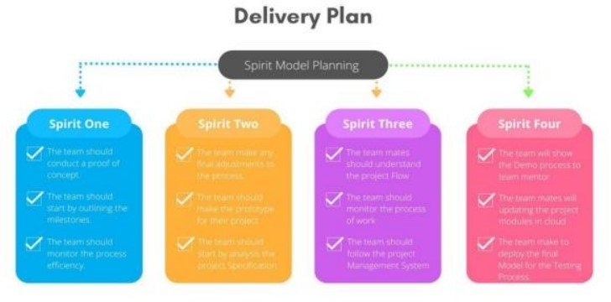

## Reports from JIRA:

JIRA has categorized reports in four levels, which are −

* + 1. Agile
    2. Detection of Items
    3. Details Generation
    4. Others

# CODING & SOLUTIONING

## Feature 1 - PREDICTION USING CNN

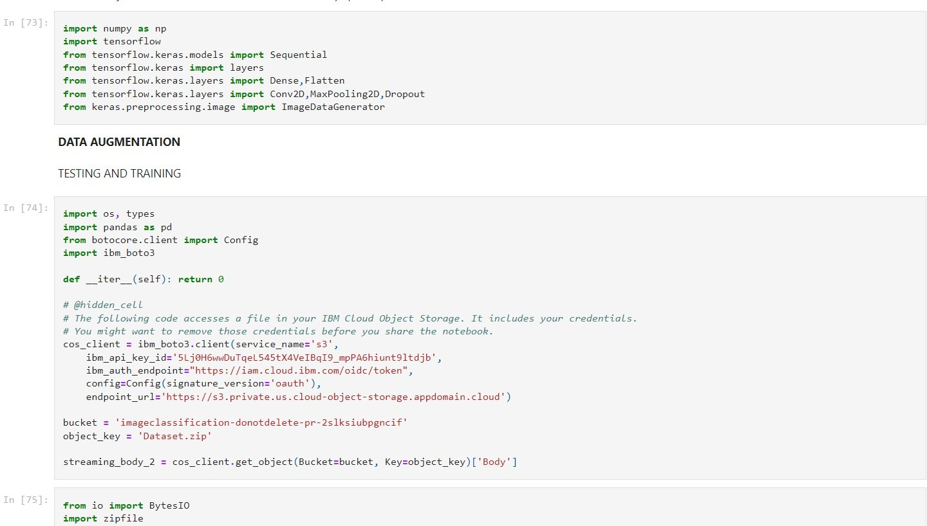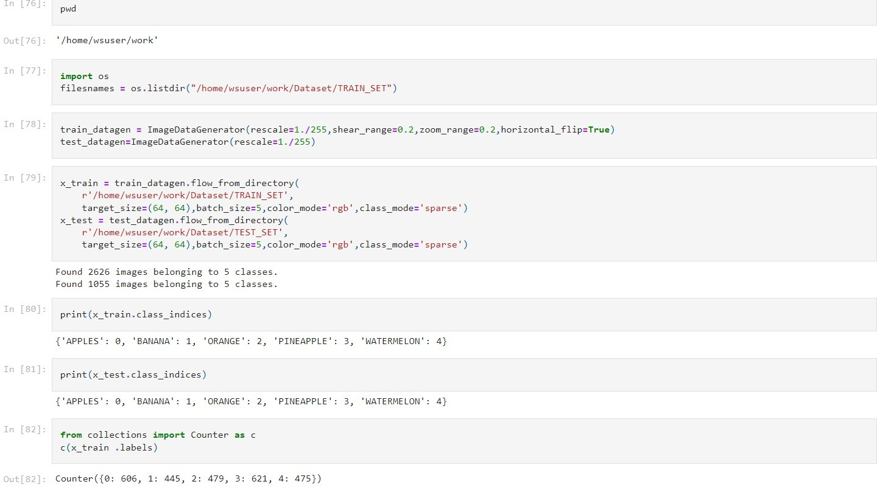

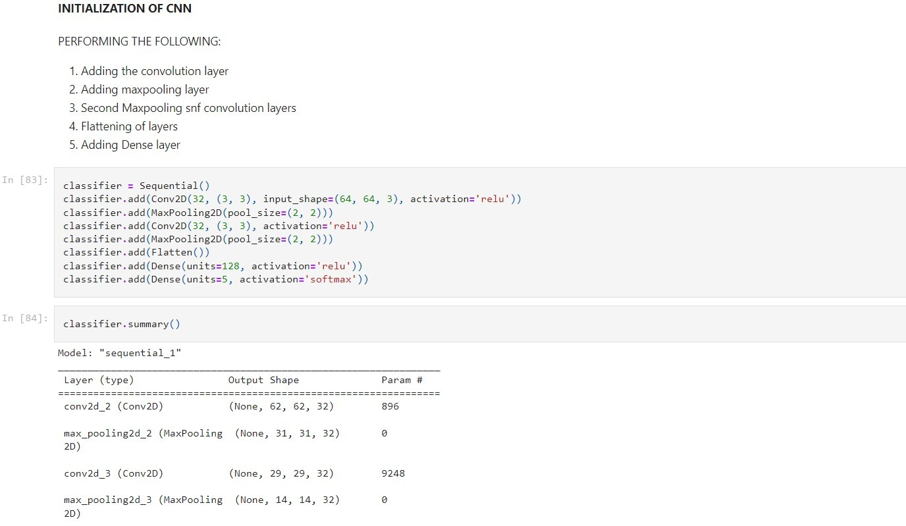

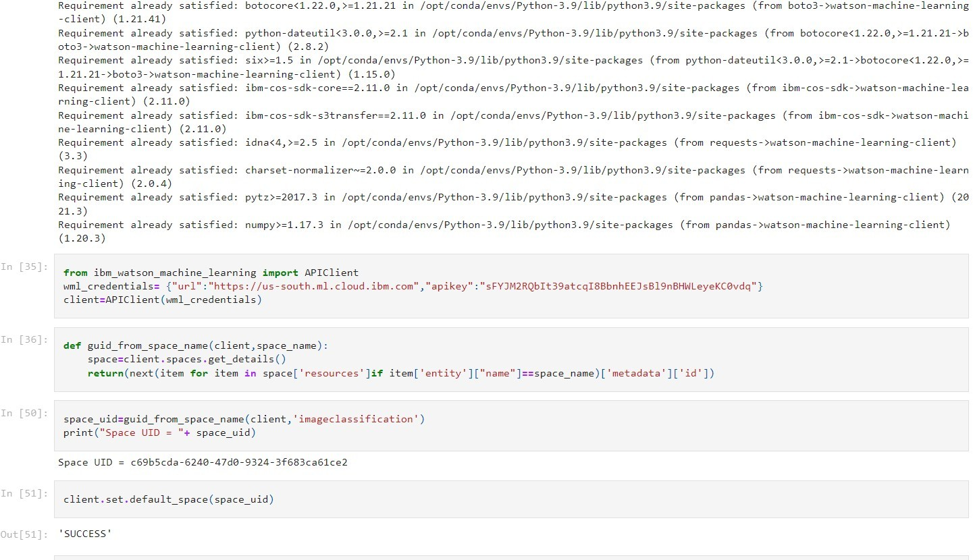

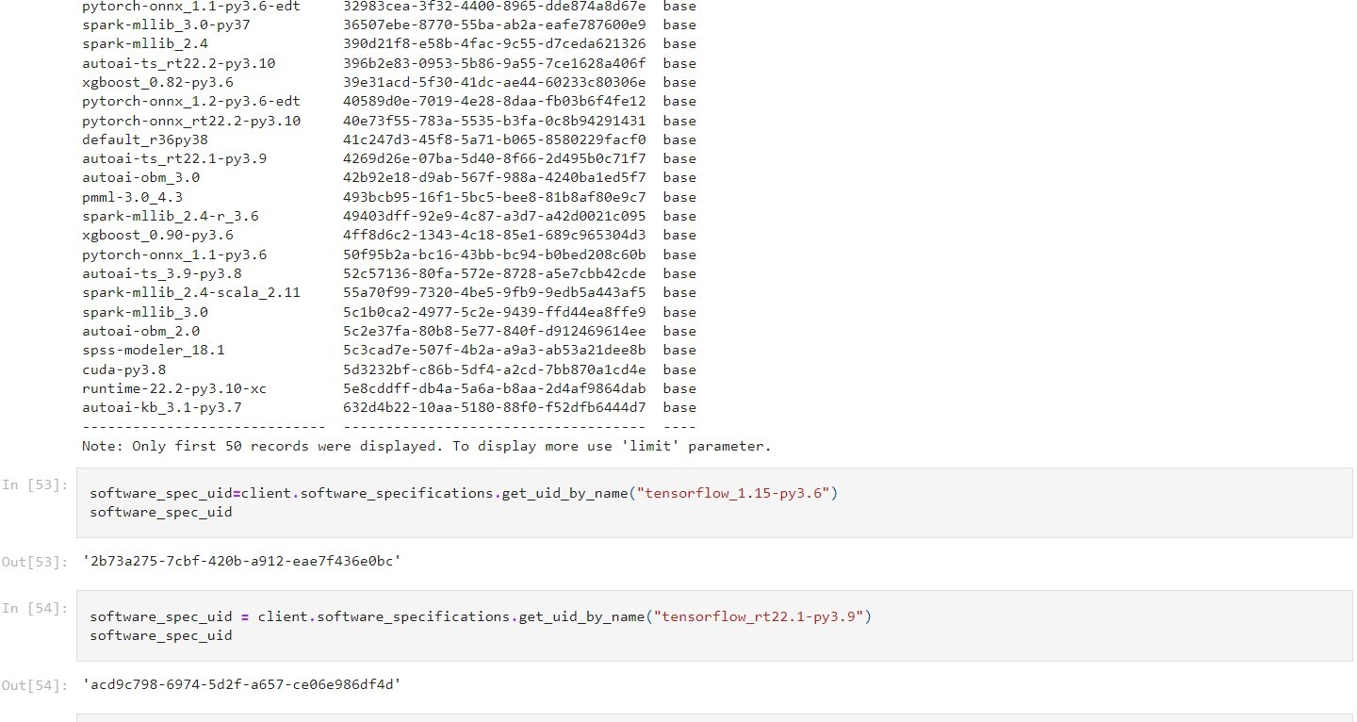

* 1. **Feature 2- DETAILS GENERATION**

import numpy as np import os

from tensorflow.keras.models import load_model from tensorflow.keras.preprocessing import image from flask import Flask,render_template,request

app=Flask(__name )

model=load_model('C:/Users/Malan/Desktop/Flask/nutrition.h5')

@app.route('/') def index():

return render_template("index.html")

@app.route('/predict',methods=['GET','POST']) def upload():

text=""

if request.method=='POST': f=request.files['image'] basepath=os.path.dirname(__file )

filepath=os.path.join(basepath,'uploads',f.filename)

f.save(filepath) img=image.load_img(filepath,target_size=(64,64)) x=image.img_to_array(img)

x=np.expand_dims(x,axis=0) pred=np.argmax(model.predict(x),axis=1)

#index=['APPLES', 'BANANA', 'ORANGE', 'PINEAPPLE', 'WATERMELON']

if pred==0: text="""APPLE===>

*Calories 96

*Protein - 0.59g

*Carbohydrate 25g

*Fats -0.39g

*Dietary Fiber 4.4g

*Sugar 14 g

*Sodium 18mg

*Potassium 194.7mg""" print(text)

elif pred==1: text="""BANANA===>

*Calories 105

*Protein 1.39 g

*carbohydrate 279g

*Fats 0.49g

*Dietary fiber 6.14g

*Sodium 1.2 mg

*Potassium 422 mg""" print(text)

elif pred==2: text="""ORANGE===>

*Calories 105

*Protein 0.9g

*Fats 0.1g

*Carbohydrate 18g

*Dietary fiber 2.39

*Sugar 9g

*Sodium 0mg

*Potassium 173.8mg""" print(text)

elif pred==3: text="""PINEAPPLE===>

*Calories 452"

*Protein-4.99g

*Fats 11g

*Carbohydrates -199g

*Dietary Fiber 139g

*Sugar 89g

*Sodium 9.1 mg

*Potassium 986.5mg""" print(text)

elif pred==4: text="""WATERMELON===>

*Calories 1371

*Protein 26g

*Fats-7g

*Carbohydrate 341g

*Dietary Fiber 18g

*Sugar 280g

*Sodium 45.2 mg

*Potassium 5060.2 mg""" print(text)

return text

if __name__=='__main__': app.run(debug=False)

**FRONT END:**

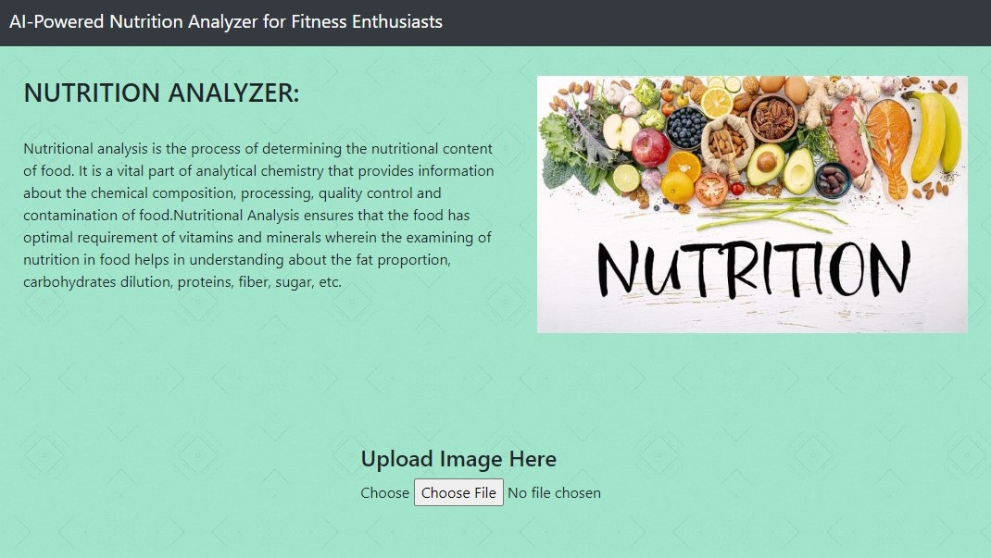

# TESTING

* 1. **Test Cases**

|  |  |  |  |
| --- | --- | --- | --- |
| **Test Case ID** | **Purpose** | **TestCases** | **Result** |
| TC 1 | Validation | Image in PDF format | Image should be in JPG, JPEG or PNG |
| TC 2 | Validation | Image in DOCX format | Image should be in JPG, JPEG or PNG |
| TC 3 | Validation | Image in BMP format | Image should be in JPG, JPEG or PNG |

# RESULTS

## Performance Metrics

* + - Tracking nutrients intake: Monitoring the diet plan and tracking all the nutrients intake.
    - Validating outcome: Capture and find the nutrients present in the given data sample.
    - Reports: The tracking app generates and sends reports to give a detailed insight about the diet plan,amount of calorie intake and nutritional value of the given sample.

# ADVANTAGES

* **Achieve your fitness goals** with a tailored web app that perfectly fits your diet.
* Deliver an **outstanding** user experience through additional control over the app.
* Control the **security** of your user data.
* Increase **efficiency** and **user satisfaction** with an app aligned to their needs.

# DISADVANTAGES

* Some nutritional software packages are of poor quality, and the technical support provided to users is sometimes **inadequate**.
* Although many excellent software packages and databases are available, they are open to **misuse** by users who do not understand or appreciate the limitations of such systems.
* This review examines some of the **sources of error** associated with the use of nutritional analysis software.

# CONCLUSION

This work provided an overview of existing AI nutrition recommender systems, a field that has experienced substantial growth in the last few years. A categorization of such systems into task specific components was presented, along with approaches concerned with each component and relevant data-sets. An assessment of the feasibility of implementing an ideal AI nutrition recommender system using current methods was also provided, with the general conclusion being that some of the required components have not reached a mature state yet.

# FUTURE

The project assists well to record the income and expenses in general. However, this project has some limitations:

* The application is unable to maintain the backup of data once it is uninstalled.
* This application does not provide higher decision capability.

To further enhance the capability of this application, we recommend the following features to be incorporated into the system:

* Multiple language interfaces.
* Provide backup and recovery of data.
* Provide a better user interface for users.
* Mobile apps advantage.

# APPENDIX

## Source Code :

**INDEX.HTML:**

<html lang="en">

<head>

<meta charset="UTF-8">

<meta name="viewport" content="width=device-width, initial-scale=1.0">

<meta http-equiv="X-UA-Compatible" content="ie=edge">

<title>Nutrition Analyzer</title>

<link href="https://cdn.bootcss.com/bootstrap/4.0.0/css/bootstrap.min.css" rel="stylesheet">

<script src="https://cdn.bootcss.com/popper.js/1.12.9/umd/popper.min.js"></script>

<script src="https://cdn.bootcss.com/jquery/3.3.1/jquery.min.js"></script>

<script src="https://cdn.bootcss.com/bootstrap/4.0.0/js/bootstrap.min.js"></script>

<link href="{{ url_for('static', filename='css/main.css') }}" rel="stylesheet">

<style>

#result {

color: #000000;

}

body {

background-color: #a0e4cb;

background-image: url("https://[www.transparenttextures.com/patterns/mirrored-squares.png](http://www.transparenttextures.com/patterns/mirrored-squares.png)");

/* This is mostly intended for prototyping; please download the pattern and re-host for production environments. Thank you! */

}

</style>

</head>

<body>

<nav class="navbar navbar-dark bg-dark">

<div class="container">

<a class="navbar-brand" href="#">AI-Powered Nutrition Analyzer for Fitness Enthusiasts</a>

</div>

</nav>

<div class="container">

<div id="content" style="margin-top:2em">

<div class="container">

<div class="row" style="height:60%">

<div class="col-sm-6 bd">

<h3>NUTRITION ANALYZER: </h3>

<br>

<p>Nutritional analysis is the process of determining the nutritional content of food. It is a vital part of analytical chemistry that provides information about the chemical composition, processing, quality control and contamination

of food.Nutritional Analysis ensures that the food has optimal requirement of vitamins and minerals wherein the examining of nutrition in food helps in understanding about the fat proportion,

carbohydrates dilution, proteins,

fiber, sugar, etc.</p>

</div>

<div class="col-sm-6">

<img style="height: 70%" src="https://[www.mlchc.org/sites/default/files/styles/max_650x650/public/2022-](http://www.mlchc.org/sites/default/files/styles/max_650x650/public/2022-) 03/nutrition_image2.jpg?itok=fUi0J40D" height="20%" ,width="5%">

</div>

</div>

<div style="display: flex;justify-content:center;">

<div>

**Python code:**

import numpy as np import os

from tensorflow.keras.models import load_model from tensorflow.keras.preprocessing import image from flask import Flask,render_template,request

app=Flask( name ) model=load_model('C:/Users/Malan/Desktop/Flask/nutrition.h5') @app.route('/')

def index():

return render_template("index.html")

@app.route('/predict',methods=['GET','POST']) def upload():

text=""

if request.method=='POST': f=request.files['image'] basepath=os.path.dirname( file )

filepath=os.path.join(basepath,'uploads',f.filename) f.save(filepath) img=image.load_img(filepath,target_size=(64,64)) x=image.img_to_array(img) x=np.expand_dims(x,axis=0) pred=np.argmax(model.predict(x),axis=1)

#index=['APPLES', 'BANANA', 'ORANGE', 'PINEAPPLE', 'WATERMELON']

if pred==0: text="""APPLE===>

*Calories 96

*Protein - 0.59g

*Carbohydrate 25g

*Fats -0.39g

*Dietary Fiber 4.4g

*Sugar 14 g

*Sodium 18mg

*Potassium 194.7mg""" print(text)

elif pred==1: text="""BANANA===>

*Calories 105

*Protein 1.39 g

*carbohydrate 279g

*Fats 0.49g

*Dietary fibre 6.14g

*Sodium 1.2 mg

*Potassium 422 mg""" print(text)

elif pred==2: text="""ORANGE===>

*Calories 105

*Protein 0.9g

*Fats 0.1g

*Carbohydrate 18g

*Dietary fiber 2.39

*Sugar 9g

*Sodium 0mg

*Potassium 173.8mg""" print(text)

elif pred==3: text="""PINEAPPLE===>

*Calories 452"

*Protein-4.99g

*Fats 11g

*Carbohydrates -199g

*Dietary Fiber 139g

*Sugar 89g

*Sodium 9.1 mg

*Potassium 986.5mg""" print(text)

elif pred==4: text="""WATERMELON===>

*Calories 1371

*Protein 26g

*Fats-7g

*Carbohydrate 341g

*Dietary Fiber 18g

*Sugar 280g

*Sodium 45.2 mg

*Potassium 5060.2 mg""" print(text)

return text

if name ==' main ': app.run(debug=False)

# Github Link :

# https://github.com/IBM-EPBL/IBM-Project-17941-1659677362

**Demo link:**

**https://drive.google.com/file/d/1F0kfT83ENlQRlqqdQlFlv7-eAYhgIdC7/view?usp=sharing**